REVIEW 2

Use Case and Sequence Diagram

General public

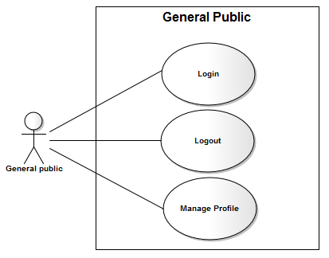

Login

Author | Hong Lam Son
Use Case Name | Login
Actors | General Public
Description | General public wants to login to website as a General public member.
Requirements | Actor provides username and password
Pre-conditions
Post-conditions | Success: General public logged in to website.  Fail: Refill information
Basic flow | Actor Actions:  1. Actor go to Home page of website.  3. Actor inputs UserName and Password, then click the Login button. | System Responses:  2. System redirects to Home page and displays Login form on the left with the following control:  - ‘UserName’ text field  - ‘Password’ text field  - ‘Go’ button  4. System checks the information  [Exception 1]  5. System redirects to Actor’s Home page.
Alternative flow | Actor Actions:  [Alternative 2]  1. Actor click ‘OK’ button, inputs UserName and Password, then click the Login button.  [Alternative 1]  1. Actor click ‘Back to Home’ button. | System Responses:  2. System checks the information  [Exception 1]  3. System redirects to Actor’s Home page.  2. System returns to Home page.
Exception | Actor Actions:  [Exception 1]  1. Actor input invalid username and password. | System Responses:  - System redirect to Login page with the following controls:  - ‘UserName’ text field  - ‘Password’ text field  - ‘Login’ button.  - ‘Back to Home’ button.  System show a message box: “Invalid Username and password”.[Alternative 2]

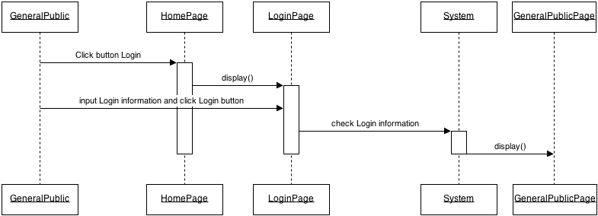

Logout

Author | Hong Lam Son
Use Case Name | Logout
Actors | General public
Description | General public wants to log out of the System.
Requirements
Pre-conditions | Actor has logged in.
Post-conditions | Success: Actor Logged out.
Basic flow | Actor Actions:  1. Actor clicks ‘Log out’ button on the Actor’s Home menu. | System Responses:  2. System redirect to Logout page, remove session, and then redirect to Login page.
Alternative flow
Exception

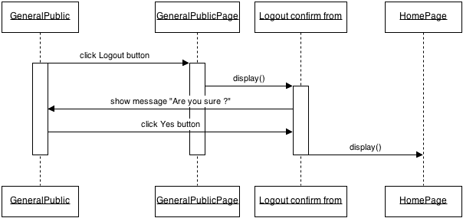

Update Profile

Author | Hong Lam Son
Use Case Name | Update Profile
Actors | General Public
Description | General Public wants to Update his/her profile’s information.
Requirements | Actor provides profile information
Pre-conditions | Actor has logged in.
Post-conditions | Success: Profile’s information of this general public has been updated.  Fail: Refill information
Basic flow | Actor Actions:  1. Actor clicks ‘Profile’ button in Actor’s Home page menu.  3. Actor updates information and click ‘Save’ button. [Alternative 1] | System Responses:  2. System redirects to Update Profile page and displays Update Profile form with the following control :  - ‘UserName’ text field (read only)  - ‘Old Password’ text field  - ‘New Password’ text field  - ‘Confirm new Password’ text field  - ‘FirstName’ text field  - ‘LastName’ text field  - ‘Gender’ checkbox group  - ‘Birthday’ text field  - ‘Address’ text field  - ‘Phone’ text field  - ‘Email’ text field  - ‘ProofID’ text field  - ‘SecurityQuestion’ text field  - ‘SecurityAnswer’ text field  - ‘Save’ button  - ‘Back to Home’ button  4. System checks the information  [Exception 1]  5. System update the account into database and then redirects to Actor Home page.
Alternative flow | Actor Actions:  [Alternative 1]  1. Actor click ‘Back to Home’ button. | System Responses:  2. System returns to Home page.
Exception | Actor Actions:  [Exception 1]  1. Actor lefts ‘New Password’ text field blank.  2. Actor lefts ‘New Confirm Password’ text field blank.  3. New Password and New Password Confirm don’t match.  4. Actor lefts ‘FirstName’ text field blank.  5. Actor lefts ‘LastName’ text field blank.  6. Actor lefts ‘Birthday’ datebox blank.  7. Input age to ‘Birthday’ datebox less than 16.  8. Actor lefts ‘Address’ text field blank.  9. Actor lefts ‘Phone’ text field blank.  10. Input phone not in numeric or phone length not in range 8 – 15 character.  11. Actor lefts ‘Email’ text field blank or input an invalid email address.  12. Actor lefts ‘ProofID’ textfield blank  13. Input proofID not in numeric or phone lenhth not in range 9 – 12 character. | System Responses:  System displays message to Actor :  - ‘Password cannot be blank’’.  - ‘Confirm Password can’t be blank’.  - ‘Confirm password not match Password.’  - ‘Name cannot be blank’.  - ‘Birthday is invalid’.  - ‘Age must over 16’.  - ‘Address cannot be blank’.  - ‘Phone is invalid’.  - ‘The phone number should be numeric only and must be between 8 and 15 digits’.  - ‘Email is invalid’.  - ‘The proofID number should be numeric only and must be between 9 and 12 digits’.

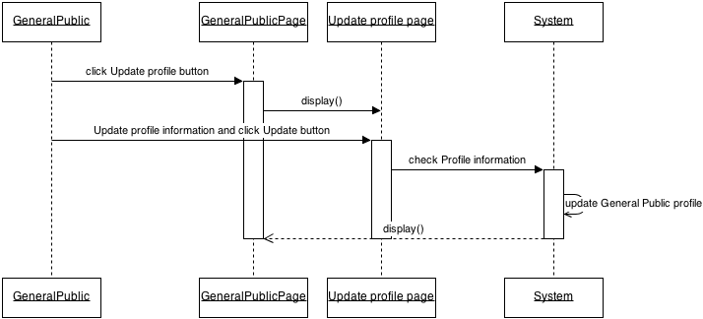

    - Search
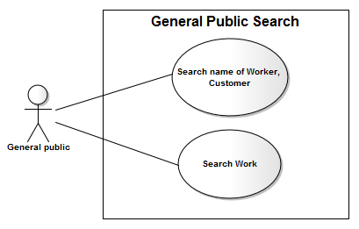

Author | Hong Lam Son
Use Case Name | General public Search
Actors | General public
Description | General public wants to search a name of Worker or search a Working.
Requirements | Actor provides search information
Pre-conditions | Actor has logged in as General public
Post-conditions | Success: Properties match the condition show up.  Fail: Do not have any property match the condition.
Basic flow | Actor Actions:  1. Actor clicks ‘Search button on the Actor’s Home menu.  2. Actor input information va click ‘Search’ button [Alternative 1] | System Responses:  2. System show the Search contains the following category:  - ‘Search’ text field  - ‘Category’ combobox  - ‘Search’ button  3.System view information on table result Search
Alternative flow | Actor Actions:  [Alternative 1]  1. Actor click ‘Back to Home’ button. | System Responses:  2. System returns to Actor Home page.
Exception | Actor Actions:  [Exception 1]  1. Actor lefts ‘Search’ text field blank. | System Response:  System displays message to Actor :  - ‘Information search cannot be blank’.

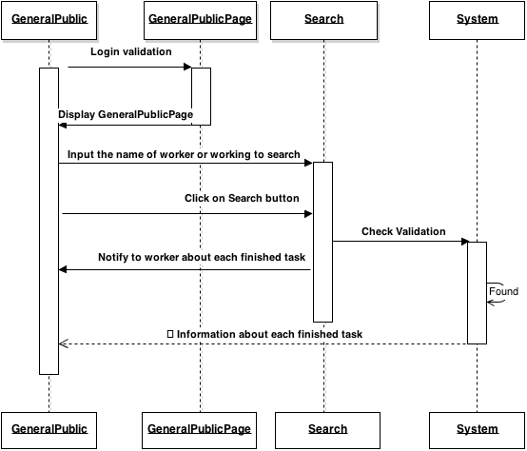
    - Thread

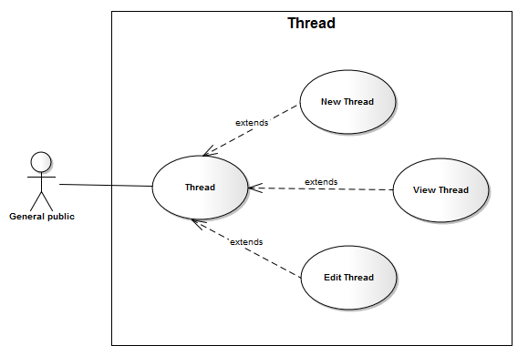

Author | Hong Lam Son
Use Case Name | Thread
Actors | General Public
Description | General Public want to submit a new thread, view thread and edit thread
Requirements | Actor provides information work and time work
Pre-conditions | Actor has logged in as general public
Post-conditions | Success: Entry information will be inserted into the database  Fail: Refill information
Basic flow | Actor Actions:  1. Actor clicks Thread button on General public menu.  3. Actor choose threads and click ‘Edit’ button  5. Actor input information and click ‘Save’ button. [Alternative 1]  7. Actor chooses New thread.  8. Actor input information and click ‘Submit’ button. [Alternative 1] | System Response:  2. System displays ‘Thread’ page  4. System displays form for Actor to input information with the following control:  - Button ‘Browse’ to upload image  - ‘workAddress’ text field  - ‘workAddress’ text field  - ‘workCity’ text field  - ‘workState’ text field  - ‘workLoc’ text field  - ‘startDate’ combobox  - ‘endDate’ combobox  - ‘startTime text field  - ‘endTime’ text field  - ‘workDetails’ text area  - ‘chargesHrs’ text field  - ‘chargesDaily’ text field  - ‘Save’ button  - ‘Cancel’ button  - ‘Back to Home’ button  6. System Update information to system  8. System displays form for Actor to input information with the following control:  - Button ‘Browse’ to upload image  - ‘workAddress’ text field  - ‘workCountry’ text field  - ‘workCity’ text field  - ‘workLoc’ text field  - ‘startDate’ combobox  - ‘endDate’ combobox  - ‘startTime text field  - ‘endTime’ text field  - ‘workDetails’ text area  - ‘chargesHrs’ text field  - ‘chargesDaily’ text field  - ‘Submit’ button  - ‘Cancel’ button  - ‘Back to Home’ button  9. System Insert information to system
Alternative flow | Actor Actions:  [Alternative 1]  1. Actor click ‘Back to Home’ button. | System Response:  2. System returns to Home page.
Exceptions | Actor Actions:  [Exception 1]  1. Actor lefts ‘workAddress’ text field blank.  2. Actor lefts ‘workCountry’ text field blank.  3. Actor lefts ‘workCity’ text field blank.  4. Input ‘workLoc’ required to 5 – 250 characters  5. Actor lefts ‘startDate’ combobox blank.  6. Actor lefts ‘endDate’ combobox blank.  7. Input ‘endDate’ more than ‘startDate’  7. Actor lefts ‘startTime’ text field blank.  8. Actor lefts ‘endTime’ text field blank.  9. Actor lefts ‘workDetails’ text area blank.  10. Input ‘workDetails’ required to 5 – 50 characters.  11. Actor lefts ‘chargesHrs’ text area blank.  12. Check input ‘chargesHrs’ is Degit and more than zero .  13. Actor lefts ‘chargesDaily’ text area blank.  14. Check input ‘chargesDaily’ is Degit and more than zero . | System Response:  System displays message to Actor :  - ‘Working Address cannot be blank’.  - ‘Working Country cannot be blank’.  - ‘Working City cannot be blank’.  - ‘Working Locale’ must be between 5 and 250 characters.  - ‘Start Date cannot be blank’.  - ‘End Date cannot be blank’.  - ‘End Date’ must be more than ‘Start Date’.  - ‘Start Time cannot be blank’.  - ‘End Time cannot be blank’.  - ‘Working detail cannot be blank’.  - ‘Working detail’ must be between 5 and 50 characters.  - ‘Charges Hours cannot be blank’.  - ‘Charges Hours’ should be degit and more than zero.  - ‘Charges Daily cannot be blank’.  - ‘Charges Daily’ should be degit and more than zero.

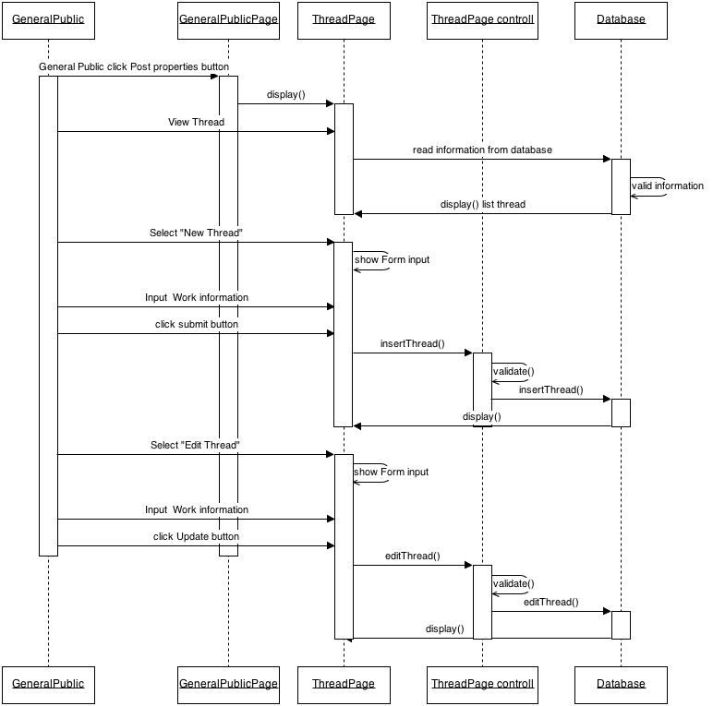
    - Manage Calendar
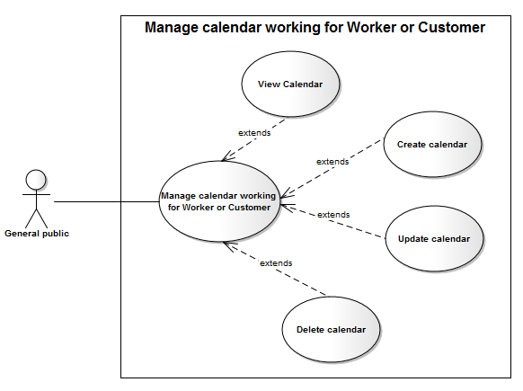
Author | Hong Lam Son
Use Case Name | Manage working calendar
Actors | General public
Description | General public
Requirements
Pre-conditions | Actor has logged in.
Post-conditions
Basic flow | Actor Actions:  1. Actor clicks ‘manage Work Calendar  3 .Actor choose Woker click ‘View Work calendar’p on the table list Woker  5. Actor click ‘Close’ button  6 . Actor choose woker and click ‘create Work calendar’ button  8. Actor Click Submit [Alternative 1]  10.Actor choose woker and click ‘Update Work calendar’ button  12. Actor Click Submit [Alternative 1]  14.Choose Worker in group and click ‘Delete Calendar’ button  16. Actor Click Submit [Alternative 1] | System Responses:  2.System showlist Worker on group  3.System Show information Work calendar of worker with  - ‘Close’ button  5. System Close view Work calendar  7. Form Create Work Calendar Show with  - droplist From Time All Of Week  - droplist To Time All Of Week  - ‘Submit’ button  - ‘Cancel’ button  [Exception 1].  9. System Insert information to system  11. Form Create Work Calendar Show with  -‘StartDate’ text field  -‘EndDate’ text field  - droplist Srart Time All Of Week  - droplist End Time All Of Week  - ‘Submit’ button  - ‘Cancel’ button  [Exception 1].  13. System Update information to system  15. pupup Confirm delete Show With  - ‘Submit’ button  - ‘Cancel’ button  13. System Delete information to system
Alternative flow | Actor Actions:  [Alternative 1]  1. Actor click ‘Back to Home’ button. | System Responses:  2. System returns to Actor Home page.
Exception | [Exception 1].  1.‘StartDate’ text field is not null  2.‘EndDate’ text field is not null  3.StartDate more less than EndDate  4.Start Time All Of Week more less than End Time All Of Week | [Exception 1].  1.System shows the message : Stardate not null  1.System shows the message : Enddate not null  3.System shows the message : StartDate more less than EndDate  4.Start Time All Of Week more less than End Time All Of Week

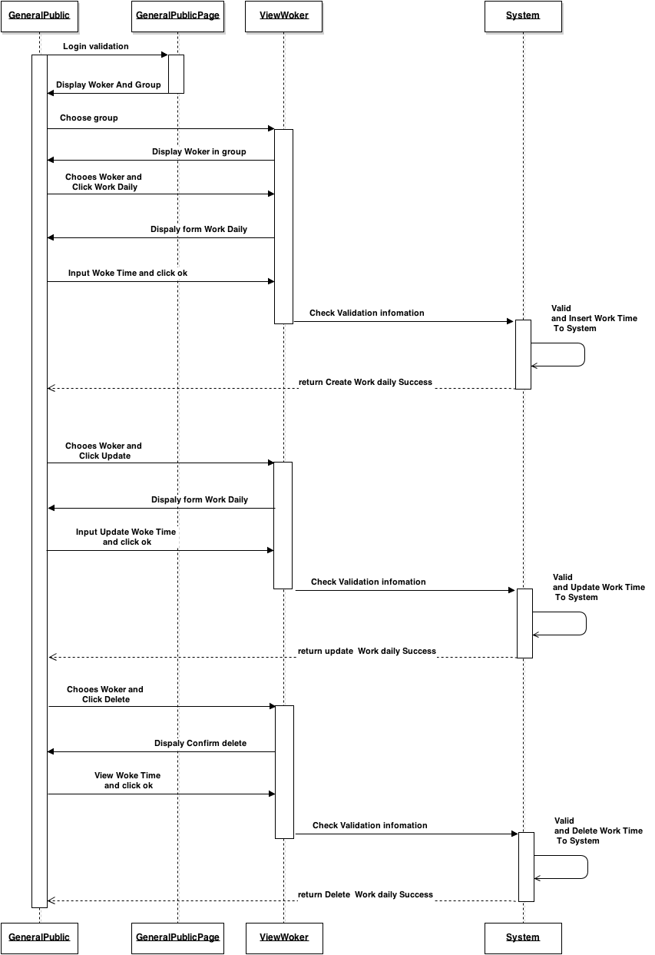
1.1.7. Rating

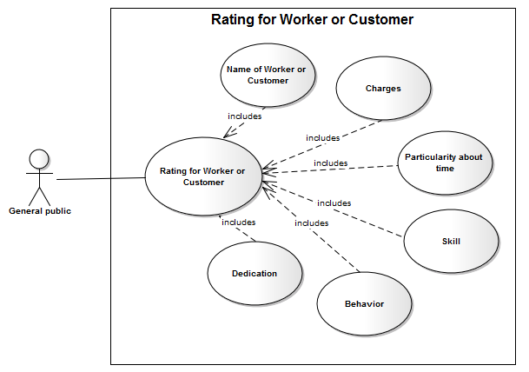

Author | Hong Lam Son
Use Case Name | Rating Woker
Actors | General public
Description | General public rating worker
Requirements
Pre-conditions | Actor has logged in.
Post-conditions
Basic flow | Actor Actions:  1. Actor clicks ‘select Woker’ button on the Actor Home page menu.  3.Actor Choose worker and click button rating to group  4.Actor input information rating and click ‘Submit’ button [Alternative 1] | System Responses:  2. System redirect to Select Worker and show list Woker  4. Form rating worker display with the following controls:  - Worker Skill  - Charges  - Particularity about time,  - dedication  - behavior  - habits  - ‘Submit’ button  - ‘Cancel’ button.  5. System checks the information  6. System Update rating to system.
Alternative flow | Actor Actions:  [Alternative 1]  1. Actor click ‘Cancel’ button. | System Responses:  2. System returns to Actor Home page.
Exception

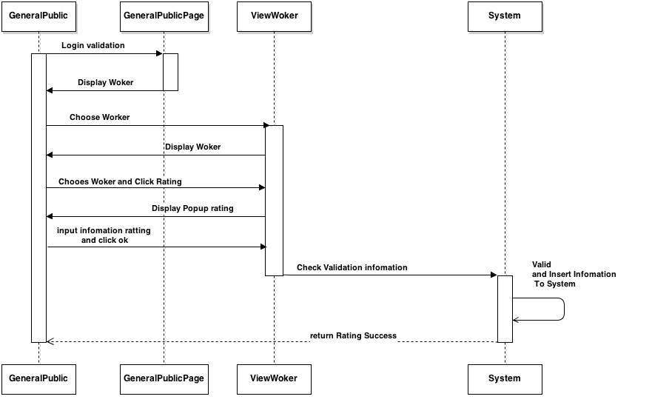
    - Feedback
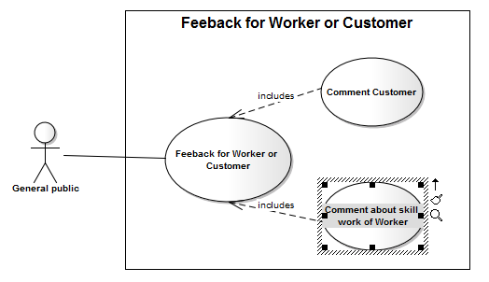

Author | Hong Lam Son
Use Case Name | Feedback
Actors | Worker or Customer
Description | General public feedback
Requirements
Pre-conditions | Actor has logged in.
Post-conditions
Basic flow | Actor Actions:  1. Actor clicks ‘Feedback’ button on the Actor Home page menu.  3. Actor inputs UserName Need feedback, Content Comment, and click ‘Feedback’ button. [Alternative 1] | System Responses:  2. System redirect to FeedbackPage and show Feedback form with the following controls:  - ‘FeedbackTo’ text field.  - ‘Content’text field.  - ‘Feedback’ button.  - ‘Back to Home’ button.  4. System checks the information  [Exception 1].  5. System Insert information Feedback to system.
Alternative flow | Actor Actions:  [Alternative 1]  1. Actor click ‘Back to Home’ button. | System Responses:  2. System returns to Actor Home page.
Exception | [Exception 1]  1. UserName is invalid, username is not null  2. Content Comment not null  3. Input Content Comment more than 20 character and less than 500 character | System Responses:  - System shows the message: ‘Invalid Username’,’username is not null’.- System shows the message:’comtent is not null, more than 20 character and less than 500 character’.

